
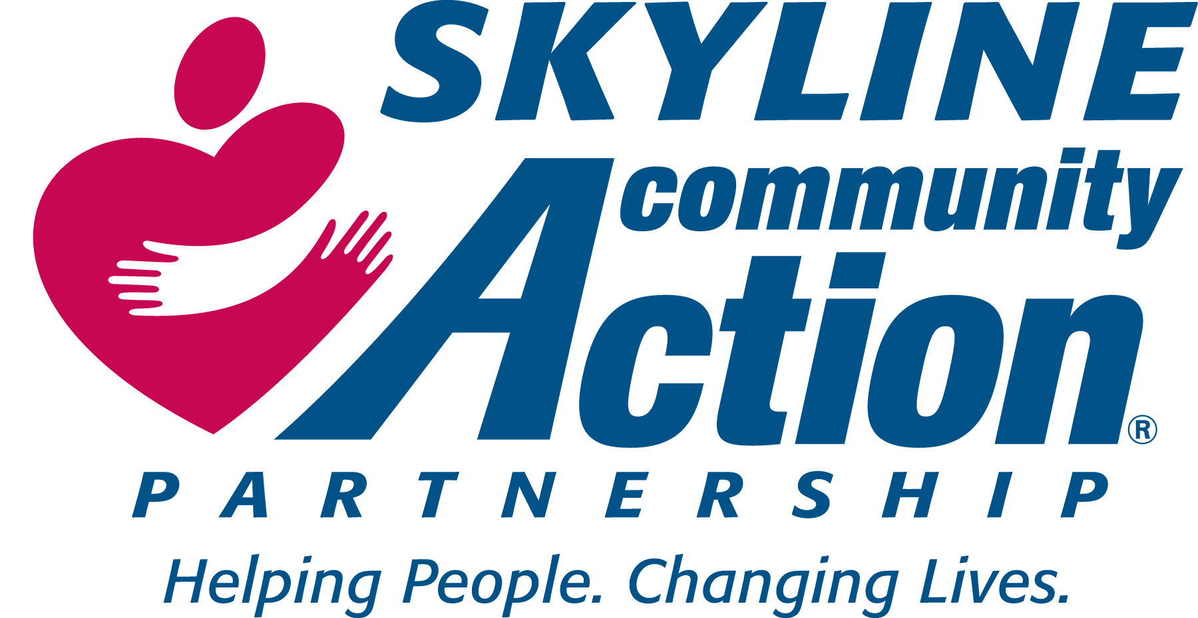
Administrative Office: Greene office:
P.O. Box 588, 45C Business Park Dr.
532 S. Main Street, Ruckersville Va. 22968
Madison, Virginia 22727 Phone: (434) 985-6066
Phone: (540) 948-2237 Fax: (434) 985-6035
Fax: (540) 948-2264
Skyline CAP Emergency Home Repair Program

APPLICATION DATE: ___________________

How did you hear about Skyline CAP’s EHR program? _____________________________________________

NAME __________________________ DATE OF BIRTH_______________SS#_____________________
SPOUSE ________________________ DATE OF BIRTH________________ SS#____________________
ADDRESS __________________________CITY____________________ STATE _____ ZIP _____________
PHONE ___________________________ CELL PHONE ________________________
EMAIL ADDRESS_________________________________________
Residence Jurisdiction: Greene County ___ Madison County _____ Orange County ___ Other _________
-----------------------------------------------------------------------------------------------------------------------------------------------------
Are you Head of Household? Yes ___ No ___ Please Indicate your gender: Female ___ Male ____

Are you disabled? Yes _____ No ______ Have you served in the Military? Yes ____ No ____
-----------------------------------------------------------------------------------------------------------------------------------------------------
For Statistical /Grant Writing Purposes Only:
Please complete both Ethnicity and Race (Check one in each category)
Ethnicity: Hispanic ____ Non-Hispanic ___ Race: White ____ Black/African American _____ Asian___
Black/African American & White ___ Other: _____
----------------------------------------------------------------------------------------------------------------------------------------------------
Do You Own this Home? Yes ___ No ___ Year House Built _____ (You must own & live in your home)
Number of Other Persons Living in Household: ____
Do they contribute to Household Support? Yes_____ No_____
If Yes, Indicate type and Amount or Value: _______________________________________________________
----------------------------------------------------------------------------------------------------------------------------------------------------
MONTHLY INCOME
(Please attach documentation for income sources in the left column)
Employment $_____________________ Checking Account $_______________________
Pensions $_____________________ Savings Account $_______________________
Social Security $____________________ Stocks/Bonds $_______________________
Other Retirement Sources $ ________________ Personal Property (Other than Home) $_____________
-----------------------------------------------------------------------------------------------------------------------------------------------------
Monthly Living Expenses
Mortgage $_____________________ Utilities $_________________ Other $___________________
Medical Expenses $ ______________________ Food $ __________________________
Please provide the following information for all household members:
Name | Relationship | Disabled  Yes No |  | Sex | DOB | Annual Income | Source of Income *
 |  |  |  |  |  | $
 |  |  |  |  |  | $
 |  |  |  |  |  | $
 |  |  |  |  |  | $
 |  |  |  |  |  | $
 |  |  |  |  |  | $
 |  |  |  |  |  | $
 |  |  |  |  |  | $
* Attach documentation/written proof of income

DESCRIBE REAIRS REQUESTED______________________________________________________________
__________________________________________________________________________________________
_________________________________________________________________________________________

Has Skyline CAP, Inc. ever assisted you before? Yes ____No ______ If Yes, when (MO/YR) ______________________

I certify that the information provided is true and correct. I understand that if I have knowingly given false or misleading information in the completion of this application, I can be denied services. I hereby authorize the release of information in support of the above.

Signature of Applicant: _________________________________ Date: _____________
Spouse Signature: _____________________________________ Date: ______________

Emergency Home Repair Program
Authorization and Release

The undersigned hereby certifies that he/she is the owner of the property located at _________________________________________________ and does hereby authorize Skyline Community Action Partnership, to make repairs and improvements as necessary and as funds area available, to the property.

The owner hereby releases and agrees to indemnity and hold harmless Skyline CAP Inc., its staff and volunteer assistance, and contractors from any liability in conjunction with the performance of the repairs and improvements.

Owner agrees to provide Skyline CAP, Inc. access to the property at reasonable times for the purpose of inspecting the work.

Owner certifies that he/she intends to occupy the property for at least one (1) year after the date the work is completed.

Owner and/or tenant agree that the quality of the installation of the materials cannot be guaranteed beyond a period of one (1) year.

Owner understands that he/she may request information as to the specific work to be done to the property prior to signing this authorization and release, and agree to the work to be performed as determined by Skyline CAP, Inc.

Owner Signature ____________________________________ Date ______________

Administrator Signature ______________________________ Date ______________

